When:
Friday, January 12, 2018
50 Targets + 2 Man Flurry
Registration: 2:00 pm
Safety Meeting: 2:45 pm
Starts: 3:00 pm
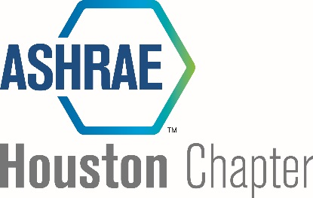
INDIVIDUAL & TEAM REGISTRATION
Fourth Annual Sporting Clay Tournament
All proceeds benefit ASHRAE Research Promotion
Where:
American Shooting Centers
16500 Westheimer Pkwy
Houston, TX 77082
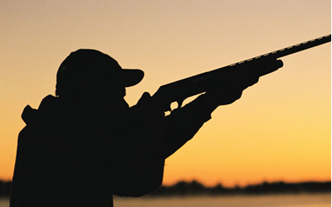
Registrations:
Single - $175
Team - $700 (quantity of 4)
Registrant #1:
Registrant #2:
Registrant #3:
Registrant #4:

Includes 50 targets + 2 man flurry, ammunition, snacks, non-alcoholic beverages before and during event. Dinner and cocktails will be provided after the event.
Registration is $175 per person or $700 for a team of 4. Mulligans available for purchase at $5 each. Limited shotguns are available for loaners. Golf carts are available for rent; contact Kurt for the form.
Contact Kurt McCulloch at kmcculloch@convergentz.com or (713) 328-3775 to sponsor or if you have any questions. Log into www.ashraehouston.org to register for the event or turn in the registration form.

